**How to add additional network.**

**Pre-requisites:**

1. **Read the SSR description carefully.**
2. **Check the reference/example server given by request in SSR.**

**Example SSR : RITM009768244**

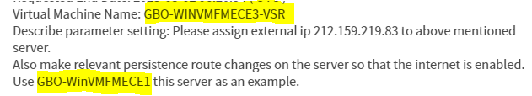

1. **Create the change request for DHC team for IPAM reservation. Ex change:**
2. **Login to given example server and collect the below information:**

**INT LAN Gateway**

**INT LAN subnet mask**

**INT LAN DNS servers**

**FED route details for IP addresses: 172.16.0.0 and 172.16.2.0.**

**Also, ping the external IP address given by requester. It should not be in use.**

1. **Log off from example server.**
2. **Login to DHC jumphost and Vsphere console and note the INT VLAN ID details from example server.**

**Implementation:**

1. **Search the VM in Vsphere console to which external IP needs to assign.**
2. **Right click to the VM and edit it, click on ‘ADD NEW DEVICE’.**

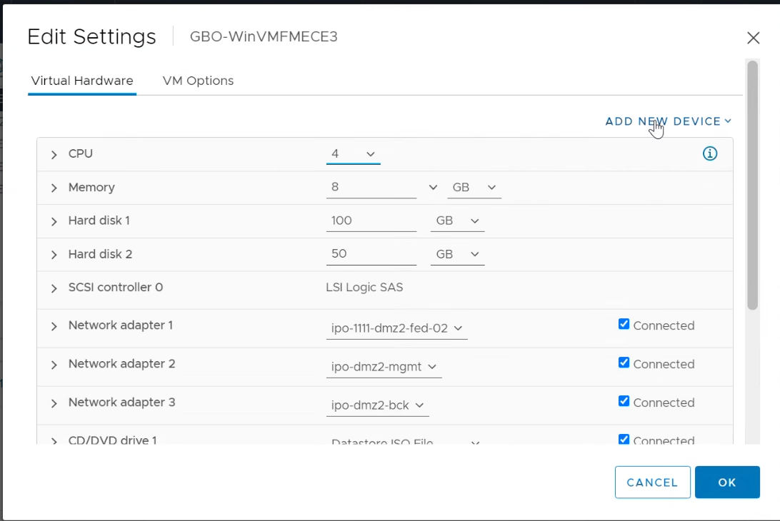

1. **Search the required VLAN and click ‘OK’.**

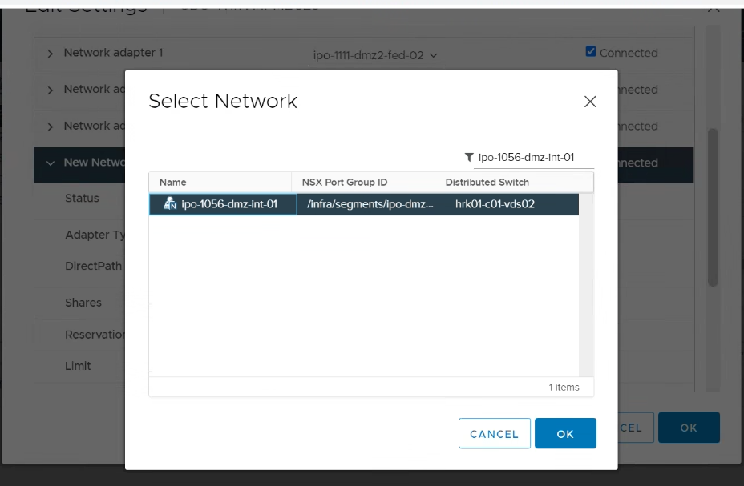

1. **Do NOT forget to change Adapter type from E100E to VMXNET3.**

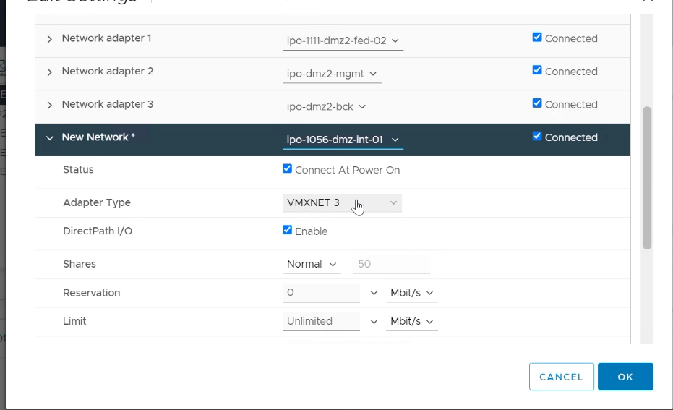

1. **Login to the server and rename newly added Adapter as “INT LAN”.**
2. **Note the FED default gateway IP address and delete it.**
3. **Configure the IP address, subnet mask , default gateway and DNS to the “INT LAN”. (IP address from ticket and other details are from step. 3)**
4. **Add the route for FED network ad below (Gateway may vary).**

**netsh int ip add route 172.16.0.0/22 "FED LAN" 172.16.2.129 <FED gateway>.**

**netsh int ip add route 172.16.2.0/25 "FED LAN" 172.16.2.129 <FED gateway>.**

1. **verify ping to INT gateway and FED gateway.**
2. **Update the ticket and inform requester.**